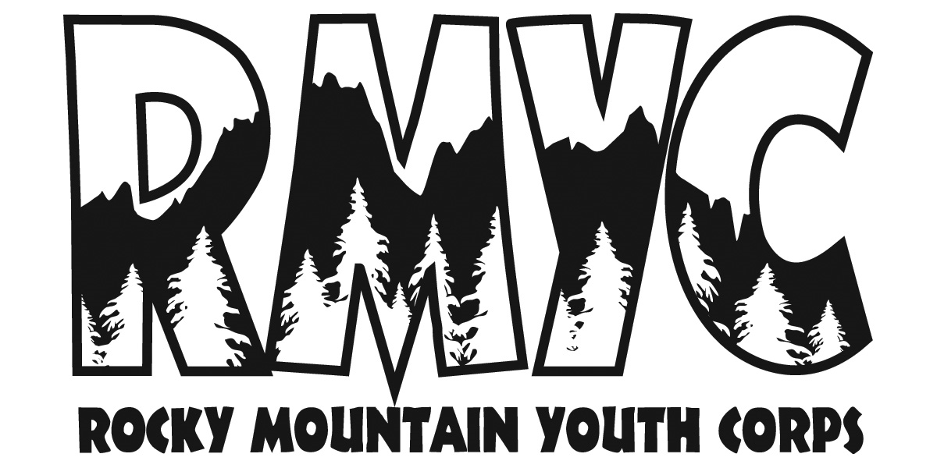

ROCKY MOUNTAIN YOUTH CORPS
Assistant Leader Position Description-2022

Position: Assistant Leader (Non-AmeriCorps)

Location: Headquarters in Steamboat Springs, CO - Crews will serve throughout the Yampa Valley

Tentative Schedule: Training: (TBD)
Season: June 6th, 2022 - August 12th, 2022
Monday - Friday; 16-32 hours a week

Compensation: $12.32 hr(20-32 hrs a week) Flexible hours between 8:00 am-4 pm M-F
Potential for 5 overnights

Overview:
Rocky Mountain Youth Corps engages youth in the outdoors, inspiring them to use their strengths and potential to lead healthy, productive lives. Assistant Leaders will provide support to Crew Leaders for crews of approximately 10 youth (11-13) in an immersive crew setting for 10 weeks with a minimum of 16 hours per week.

Overview of Service Learning Crew: The Service Learning Crew enhances the sense of belonging and connectedness of youth to their communities through meaningful outdoor-based service projects, education, and group recreation activities. The education component of SLC consists of job readiness, leadership skills, life skills training, environmental education, and civic and social responsibility. Participants are ages 11-13 and volunteer their time for community service hours (unpaid) on a crew of 2 leaders and 10 participants. Five 2-week sessions, Monday - Friday, 8 am-4pm with one overnight camping day (leaders work 7:45am-4:30pm)

Duties and Responsibilities:
- Support Crew Leaders and mentor a crew of 8-12 volunteer crew members (varies by crew) in all day-to-day activities, on the project site and on the overnight trip, and recreation time.
- Support the physical and emotional well being of the crew members
- Participate in RMYC Crew Leader training workshops
- Complete daily and weekly documentation of crew service and activities, time spent serving
- Support leaders in base camp operations including camp set-up and meal preparation
- Coordinate projects and logistics with RMYC Staff, Field Coordinator, and Project Partners
- Report regularly to the SLC Crew Leader
- Facilitate 1 Seed Lesson each week in conjunction with daily schedule
- Perform duties expected of any corps member including service work, meal preparation, cleanup/setup, and other day-to-day duties
- Adhere to and enforce rules and regulations as specified in the RMYC Employee Guidelines Handbook

Qualifications:
- Must be at least 16 years old and live in Routt County
- Ability to work on diverse teams
- Strong organizational skills
- Ability to work independently and take initiative
- Must be able to provide proof of eligibility to work in the United States

The Service Learning Crew Junior Leader position is classified as a Seasonal Exempt position.
https://www.rockymountainyouthcorps.org/employment

Rocky Mountain Youth Corps is an Equal Opportunity Employer. Rocky Mountain Youth Corps is committed to the inclusion of members with all levels of ability. Reasonable accommodations are available upon request. This program is available to all, without regard to race, color,
national origin, disability, age, sex, political affiliation, or religion.

Rocky Mountain Youth Corps 991 Captain Jack Drive, Steamboat Springs, CO 80477
info@rockymountainyouthcorps.com (970) 879-2135 x105 www.rockymountainyouthcorps.org

